**BX3082: INTERNATIONAL MARKETING**

**Table of content**

**1. Introduction 5**

**2. Situation analysis 5**

**2.1. PESTLE 5**

**2.1.1. Political: 5**

**2.1.2. Legal factor: 6**

**2.1.3. Economic factor: 7**

**2.1.4. Social factor: 8**

**2.1.5. Technological factor: 9**

**2.1.6. Environmental factor: 10**

**2.2. Consumer Behavior: 11**

**2.3. SWOT 11**

**2.3.1. Strengths 13**

**2.3.2. Weaknesses 13**

**2.3.3. Opportunities 14**

**2.3.4. Threats 14**

**2.4. Competitive analysis: 15**

**3. Marketing plan 17**

**3.1. Marketing plan and objectives: 17**

**3.2. Market entry strategy: 18**

**3.3. Target market: 18**

**3.3.1. Demographic 19**

**3.3.2. Geographic 19**

**3.3.3. Behavioral 19**

**3.3.4. Psychological 19**

**3.4. Positioning: 20**

**4. Marketing mix 20**

**4.1. Product 20**

**4.2. Place 24**

**4.3. Price 25**

**4.4. Promotion 27**

**5. Budget 31**

**6. Marketing control 31**

**7. Conclusion 33**

**Table of Figure**

**Figure 1: Hostede’s Dimension in China and Myanmar 9**

**Figure 2: Consumer Behavior Model 11**

**Figure 3: SWOT Analysis 12**

**Figure 4: Competitor analysis 15**

**Figure 5: Target market 19**

**Figure 6: Low price & Low variety 20**

**Figure 7: Product Life Cycle 21**

**Figure 8: Product layer 21**

**Figure 9: The comparison between two countries 23**

**Figure 10: Price comparison 26**

**Figure 11: Price Framework 26**

**Figure 12: Monthly active Facebook users 29**

**Executive summary**

The report outlines the Direct exporting that makes Li-Ning enter the Yangon, Myanmar market, in order to provide the sports shoes products with reasonable price and high quality for Myanmar people. There will have a deep analysis about the introduction phase about Products life cycle, the position of near upper limit in Pricing framework and Promotion strategy including TV, Facebook, WeChat, events sponsorship, outdoor advertisement and celebrity endorsement advertisement that is vital to enhance the brand awareness in Myanmar market.

In order to run the successful marketing strategy, the PESTLE and SWOT analysis will be researched to gain the marketing objectives and compete with 3 competitors existed in Myanmar, namely Adidas, Nike and Skechers.

Due to the first times enter Myanmar market, Li-Ning only focuses on people aging from 15 to 64 having middle to high income. Therefore, it will achieve the marketing objectives in 1st year that obtains about 50% of brand awareness and makes up 15% market share in Myanmar.

# Introduction

According to the AusPlay April 2017 Stat and Territory Results, it is indicated that 71% national adult aging from 14 to 65 years participated in sport or physical activity twice a week, 60% national adult 3 times a week and 48% national 4 times a week, which means that the sports play a crucial part of people’s life and obtain the increasing attention from people’s concern (NSW Government, n.d.). With this trend of sports, the sports brand company has developed dramatically and become the integral part of market.

Li-Ning as one of the leading sports brand in China mainly provides the products related to sports apparel such as footwear, equipment and accessories for professional and leisure purposes and founded by Mr. Li Ning – a champion gymnast. The company was established in 1980 and spent lots of efforts in sponsoring sports matches to push the development of athletic goods. Gradually through times, Li Ning has become a well-known international sports brand in representation of China. Li-Ning also owns the mature and widespread supply chain management system in the mature retail distribution network in China (LI-NING, n.d.). With the fierce competition and globalization, it is necessary for Li-Ning enter different countries to expand the business and increase the brand awareness. Since Myanmar has the policy and open market for the foreign company, Li-Ning can expand its business into the market of Myanmar.

This report will focus on the method that how Li-Ning can enter Myanmar country and open the outlet in Yangon. This report provides the perception of the market environment analysis and SWOT of Myanmar in order to have the deep understanding and analysis of the new market condition. Then, the reasonable marketing goal and objective will be established for the Li-Ning. In addition, the marketing entry strategy will be proposed for better performance and the description and analyzation of the marketing mix will be demonstrated and each element will be adapted different way in Myanmar. In the end, the marketing control and budget will be offered and calculated in detail for the future development and operation.

# Situation analysis

## PESTLE

### Political:

Myanmar has been undertaking a series of political and legal reforms that induce the significant transformation such as from the military rule to democracy, from the centrally directed economy to the market-oriented economy (The World Bank, 2017). In order to boost the economic growth from the decades of conflicts toward peace, the new investment law was imposed through the agreement of Myanmar’s Directorate of Investment and Company Administration (DICA), the International Finance Corporation (IFC). (The World Bank, 2017). In 2017, the new investment law has offered a more cohesive and modern legal framework for the foreign company, which aims to stimulate the foreign investment and simultaneously expand job opportunities for local people in Myanmar (New Investment Law, 2017).

Therefore, it provides the corner-stone for LiNing entering the market of Myanmar. The company displays the sports shoes products in the Myanmar market, which will achieve the win-win condition, the equal competition with between Li-Ning and Nike, Adidas and the equitable treatment in terms of Product, Price, Promotion and Place. It means that there is the mutual benefit between the streamlined domestics, the job employability in Myanmar and the protection of businesses interests running in Myanmar.

### Legal factor:

Although Myanmar’s government is working intensively to seek for more private investments across all sectors, the weakness country is the lack of governance experience which cause the policy implementation delays. For example, from 2016 to 2018, the government had only released 12-point economic policy (AIG, 2018). Although the Myanmar Investment Law was passed in November 2016, it was only enacted in February 2017. Furthermore, new Company Law passed in December 2017 had not finalized its bylaws and guide lines and the enact date for this framework has been delayed to August 2018.

Myanmar has the high risk in political and legal factors, which achieves about 2.6/10.0 (AIG, 2018). Myanmar’s overall economic policy is largely affected by the ethnic armed groups. Although a peace is undertaking, the agreement has not yet been signed. Thus, the government tends to encourage investments in parts that are lacking economic development. Furthermore, Myanmar aims to further international trade and investment by removing the needs for investment permits from the Investment Law 2016. Moreover, the Company Law 2017 which was enacted in August 2018 will also increase “the threshold for foreign investment in domestic firms from 0% to 35%, opening up a range of activities to foreign firms” (AIG 2018).

Therefore, it raises the higher level of challenges and risks for Li-Ning’s business to penetrate the Myanmar market. The businesses strategies and plans will encounter the delayed implementations or failures due to the instability of law enforcement. This will postpone the launch of new product or stores, the proposed pricing strategies, the selection of distribution channels, the allocation of budget about promotional activities.

### Economic factor:

*3.1.3.1. Economic analysis*

It is interesting to notice that after the transition of democracy in 2011, Myanmar has been decreasing the taxation from 45% to 25% for locals and foreigner businesses, which provide the competitive advantages the foreign company to enter Myanmar (PWC, 2017). In fact, China ranked top in foreign investments in Myanmar, which was USD18,392 million (PWC, 2017). This makes the prime advantage for Li-Ning business due to the headquarters in China.

One-third of Myanmar’s population lives in poverty in spite of a sharp decline in poverty over the past decade. The GDP was USD$67.4 billion (Euler Hermes, 2018). The poverty in the rural and urban area is around 38.8% and 14.5%, respectively (Chau, 2017). There was a strategy conducted by the Country Partnership Framework (CPF) which transforms the nutrition, health, education, infrastructure (Chau, 2017). However, Myanmar is still recognized as one of the fastest-growing economies in Southeast Asia with a decline of poverty population, which fell from 48% to 32% between 2005 and 2016 and the economy is forecasted increase to 6.4% in 2017/18 compared to 5.9% in 2016/17 (The World Bank, 2018). The average economic growth increased by 7.5% between 2012 and 2016 and the young population is the crucial force to ensure the growth in consumption and income between 2015 and 2025 (The Myanmar Times, 2018).

Therefore, the price of Li-Ning product will maintain the same price with China due to the current Myanmar’s economic condition and the target market. The young population becomes the vital part of higher consumption and income. Hence, the Li-Ning target market is the young generation where the incomes ranges from middle to high income. The increasing improvement of individual’s income shows that local customers are willing to have the purchasing power to afford the Li-Ning’s products. The potential for sustainable growing economy and the positive change from young population can directly benefit the maximum of potential customers and the purchase behavior in Myanmar.

*3.1.3.2. Market Size Assessment*

It is necessary to estimate the potential target market population in order to better understand the Myanmar market situation. Myanmar population is about 55,447,010, which consists 27.5% of the population under 15 year olds, 67.5% the population between 15 and 64 year olds and 5% of population above 65 year olds (Myanmar Population, 2018).

Therefore:

The population under 15 year olds:

55,447,010 * 27.5% =15,247,927.8

The population between 15 and 64 year olds:

55,446,010 * 67.5% = 37,426,056.8

The population above 65 year olds:

55,446,010 * 5% = 2,772,350.5

Based on these calculation, the target market ranging from 15 to 64 years old are around 37,426,056.8. The over 37 million people in Myanmar will become the potential customer for Li-Ning’s business. The target market includes not only the young generation who can contribute to the consumption but also have the middle-high class who have the purchase power, which is the huge population as Li-Ning target market to meet the profit margin. The continuous increase of the young population and improvement of economic will continue to provide the advantage for the future of Li-Ning development in Myanmar.

### Social factor:

Myanmar economy is mainly supported by the service sector, which contributed approximately 38.7% to the total GDP in 2016 (BusinessWire, 2017). The country follows a Sustainable Development Goal which prioritizes capital expenditure, encourages private investments and creates jobs for the locals to improve life quality. Their government focuses on the development of the nation’s economy by encouraging consumer spending with education reforms and upgrades in production and services (BusinessWire, 2017).

The government also focuses on the development of the nation’s economy by encouraging consumer spending which may prevent the risk of being neglected in the market. The local people are expecting unique offerings in production and services, which results in the behavior of ‘opening-arms’ to new foreign brand such as Li-Ning. Pricing of product may also increase slightly (Environmental, Social and Governance Report, 2014).

|  |  |
| --- | --- |
|  |  |

Figure 1: Hostede’s Dimension in China and Myanmar

From Figure 1, it shows that both countries have high level of power distance when communicating, which is a feature for Asian countries. However, Myanmar skews on the feature of Collectivism than China. It means that Myanmar people prefers getting together with many people when they live and they appreciate the role of female in Myanmar society than China. The main disadvantages is that most of people in Myanmar have higher level of trying new things in society where there is a higher level of uncertainty avoidance

### Technological factor:

Internet technology has developed rapidly in Myanmar. Internet users grew by 97 percent a year, and mobile penetration reached 80 percent (Hynes, 2017). The Burmese people spend most of their time on social networking sites, which are young people. In addition, the WeChat platform has entered Myanmar and become one of the popular social media in the region. MySQUAR is a Burmese social media, entertainment and payment platform that has signed a non-exclusive agreement to sell and promote WeChat's advertising products and services in Myanmar. The WeChat agreement involves the advertisements from Myanmar advertisers targeting the Chinese visitors in Myanmar and WeChat Myanmar resident users (THIHA, 2018). Therefore, online social media will be a good approach to reach our target customers.

Moreover, television is still the most popular and influential media. This will support the promotion vehicle. Although Myanmar's mobile and Internet users are increasing rapidly, Internet penetration is still relatively low. Hence, the combination of TV and social media will focus on the target customers (Thongtep, 2013).

Since 2011, Myanmar’s economy has transformed, which creates the change of technology. Therefore, the Li-Ning business will bring about the advanced technology to the outlet in Yangon such as the creation of 4D model virtual fitting on the company website. The system provides some parameters about the height, weight in order to help consumers match the shoes they want.

Moreover, Myanmar's rubber industry ranks high (Parker, 2016). Therefore, it helps Li-Ning provide the products with the local quality and create the advantage about offering the reliable and close shopping experience.

### Environmental factor:

Environmental pollution is an alarming issue in Myanmar, especially in Naypyidaw regarding to air and plastic pollution. For the air feature, according to the record of WHO – World Health Organization, Myanmar is one of the most polluted country in the world (MyanmarTimes, 2016). The air indicator measured in Myanmar’s urban and rural areas is 51, which is considered as unsafe level for human to breathe and the air pollution involves the inefficient modes of transportation, lighting and heating (MyanmarTimes, 2016). For the water element, Myanmar also encounters the issue of water in terms of pollution and cleanliness. There is a low level of water quality, which makes up only 28.41 and high level of drinking water pollution and inaccessibility, which consists of 69.15 (Numbeo, 2018). For the plastics feature, there are about 80 million plastics bags used per day in Myanmar (Helsingen, 2018). This results in the serious plastic pollution in Myanmar.

Therefore, the utilization of sustainable environment policy will help the Li-Ning company run the business successfully in Myanmar. In order to distribute the Li-Ning’s products to the outlets with the emission level in the acceptable level in Naypyidaw, the eco-friendly vehicles must be used which are suitable for the infrastructure in Naypyidaw, which will eliminate the problem of air pollution. To solve the water pollution, the installation of Water Purifier at the outlet will become the possible approach, which ensures the health of staffs. The provision of paper or biodegradable packaging bags and the policy of returning packaging bags will address the plastics pollution in Naypyidaw.

## Consumer Behavior:

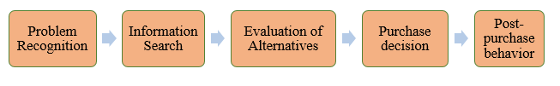

Figure 2: Consumer Behavior Model

There are 5 steps that makes the consumers consume the products, which is provided by Figure 2.For the Problem recognition, more than 37 million of Myanmar people acknowledge the expensive price about sports shoes products where the competitors include Adidas, Nike and Skechers in the market, which requires a significant spending on primary-demand product. It is vital to recognize that Myanmar is still a developing country where the income is still low that poses a threat for them to buy the luxury brand products. Hence, the Myanmar people will find the information to find the reasonable price based on the advice from friends, relatives and on the Internet due to Collective society behavior in Myanmar. The consumers based on the experience about buying the products related to color, quality and function, warranty policy.

Through the collected information, there will have a detailed comparison between brands, price, design, relevant policy. Then, they will conduct the activity of buying the products at the outlets and if the purchased products meet their requirement, they will return back the outlets again, which means that they will become the loyal customers. The Li-Ning business achieves the higher level advantage due to the lower price than competitors which will be analyses below and strong brand fame about qualified sports shoes products in China.

Due to the first time enter the Myanmar market, the target market is only people aging from 15 to 64 with the income ranging from middle to high income. From the consumer behavior analysis, the Li-Ning business ensures that it will reach the marketing plan and objectives including the increase number of all customers regardless of income and age, gain 90% of brand awareness and open 6 outlets in Myanmar.

## SWOT

|  |  |
| --- | --- |
| Strengths | * The top brand image of sports apparel manufacturer in China since 1990. * Achieve the endorsement advertising strategy * Strong corporate financial by sponsoring the Olympic games and other sports events, conducting contract with famous athletes. * Providing permanent commitment for technology innovation and professional sports goods. * Adding the product unique features through the collaboration of engineering researchers, leading universities and research institutes. * Possess a comprehensive distribution network that includes the supply chain management system and retail network. |
| Weaknesses | * Lack of fashion designs, which results in the loss of customers * Decrease the competitive advantage compared to Nike and Adidas, even in the China’s market. * Frequently adjust the advertising themes which cause the customers’ confusion about the product strategy. * In China, the main target market is Chinese students aging below 24 years old, which means that there is an ignorance of young population aging from 25 to 34 (Escande, 2015). |
| Opportunities | * The strategy of “The Last Border of Asia” has created the investment explosion towards Myanmar. * An increase of the Burmese population disposable income boosts the high level of purchasing power * There is a high degree of healthy awareness and sports lifestyle * The government creates a conducive environment for foreign investment to Myanmar’s economy such as a foreigner business can hold 35% of the shares of a local company and a company with more than 35% of foreign investment is classified as a local company. * One outlet locates in Yangon creates the optimum opportunity for achieving the target market as proposed |
| Threats | * High level of **Uncertainty avoidance and Collective society** from the Myanmar people * The disunion of legislation and the economic policy result in the postponing of opening the outlet in Yangon * The moderate level of long-term orientation becomes the hindrance for the development of long-term strategic marketing |

Figure 3: SWOT Analysis

#### Strengths

It is undeniable that Li-Ning has been considered as the top China’s sports apparel maker and a strong brand image since 1990. Li-Ning has sponsored not only for China sport such as Olympic games and athletes but also abroad sports activities. Li-Ning has the cooperation with the national team and provides the equipment for China national team of Diving, Shooting, Ping-Pong and Badminton. In the international situation, Li-Ning also holds the contract with foreign famous athletes such as Dwyane Wade and Marin Chilic. (Gu, 2018).

In addition, Li-Ning has the long-term commitment that seeks for the innovation of technology in product and, which promise to offer professional sports goods. Li-Ning has the cooperation with engineering researchers, leading universities and research institutes in order to do the development of the functional product. Li-Ning is the first company that has its own R&D facilities in China and established the Design Center in Hong Kong for product design in 2004, which assists the innovation and attractive design of Li-Ning product (Li Ning, n.d).

Moreover, Li-Ning has a comprehensive distribution network that includes the supply chain management system and retail network. It is indicated that Li-Ning company is continuing growth and development, Li-Ning added around 800 stories a year from 2004 to 2008 and has more than 7,000 stores in 2010, which make up 14.2% of China market share for sports gear (O’Rourke, 2010).

#### Weaknesses

The utmost weakness of Li Ning is the lack of trendy designs which cost the brand a great loss of customers. This makes it uncompetitive against major rivals such as Nike and Adidas, even in the China’s market. Furthermore, Li Ning also changes their advertising themes too often which makes it seems as if the brand has no unclear product development plan. For instance, their products are sometimes perceived as “professional use”, whilst at other times, they can be seen worn for ‘casual use’. Therefore, the brand lacks a clear association of whether it is trendy or competent

Moreover, in China, Li Ning only focuses on university students, it has lost significant market shares. Because the brand did not target the market segment effectively by missing out the young adult’s population aging from 25 to 34. It also did not aim at the higher income groups, sport-active people, and cities with strong purchasing power and trend-setting effect. Such severe lacking opens opportunities for local brands to have competitive advantages and threatens Li Ning’s share in the market.

In order to offset the loss of market share in China, Li Ning will open the outlet at Yangon. The target market will be the local people having middle to high income.

#### Opportunities

Since 2011, the explosive growth and untapped potential of the Myanmar economy has led many investors to call the country “the last border of Asia”. The average annual growth rate of Myanmar’s GDP is 8.6% (Directorate of Investment and Company Administration, 2019). As the disposable income of the Burmese population continues to increase, there is a growing need for higher quality shoes, especially sneakers. The footwear industry is a very important part of the Asian economy and ASEAN countries are seeing a pattern of growth in the footwear industry.

In Myanmar, the footwear on the market is mainly composed of slippers and sandals. It is mainly composed of small and medium-sized enterprises, but there are also a few factories that produce sports shoes. Burmese are now more aware of their health and sports and want to have a healthy and sporty lifestyle. Therefore, in the future, sports shoes brands will have more opportunities to enter Myanmar.

In addition, the government creates an environment conducive to investment to attract more direct investment from the state. For example, a foreigner can hold 35% of the shares of a local company, and a company with more than 35% of foreign investment is classified as a local company. Foreign investors can hold shares in listed companies in the Yangon Stock Exchange (YSX) and YSX stock transactions. These are all attractive features that attract foreign direct investment in Myanmar (ASEAN Today, 2017).

#### Threats

According to Hofstede dimension, there is a high level of **Uncertainty avoidance and Collective society** from the Myanmar people. Therefore, it would cause the failure or hesitation of accepting the international brand. The lack of individual decisions influences the willingness to purchase the products. If a group satisfies with products quality, they will use word-of-mouth strategy to promote the product to their friends, relatives. If a group does not satisfy with products quality, they will boycott the Li-Ning brand.

According to Hofstede dimension, the moderate level of long-term orientation becomes the hindrance for the development of long-term strategic marketing. Due to the strategy of running the sustainable business in Yangon, the low level of long-term orientation from the governments will not make the Li-Ning conduct the long-term strategic marketing.

There is high possibility of the disunion of legislation and the economic policy placed on the hands of ethnic groups result in the postponing of opening the outlet in Yangon. The lack of licensed outlet will make the Li Ning company not open the business here.

## Competitive analysis:

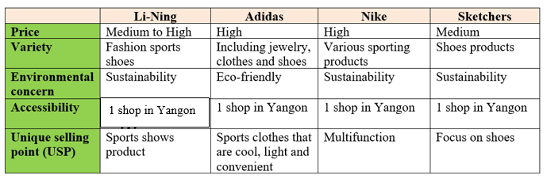

Figure 4: Competitor analysis

*2.4.1. Nike brand:*

According to Forbes' list of the world's most valuable brands, Nike's brand value reached $29.6 billion. Nike Inc's annual revenue for the fiscal year 2017 increased 6.1% to $34,350.00 million, compared to $32,376.00 million for the same period last year (Nembhard, 2018).

Nike's position as the most valuable brand in the world, in addition to its excellent brand strategy, is also related to advertising endorsements and inquiring about global celebrity endorsements. These sports stars are recognized and have a high reputation and popularity. For example, the football star named Cristiano Ronaldo, the basketball star named Kobe Bryant and the tennis star named Roger Federer. These sports stars are equally well known and influential in Myanmar, especially the football star named Cristiano Ronaldo.

In Myanmar, the most popular sport is football. Football is the sport that draw a tremendous attraction to local people. Watching football is their own combination and public gathering. With the help of the star effect, sales have gradually increased. Nike spends a lot of money on advertising each year. Nike has spent a total of $8 billion since 2002 (CNN Business, 2015).

Nike products are a globally unified strategy and the products in any store around the world are the same, with no regional restrictions or differences. Nike entered Myanmar late but the locals already have an understanding of the brand. In addition, the logistics system and warehouse operations are informational, so it can improve efficiency and bring convenience.

*2.4.2. Adidas brand:*

Adidas sports products are made of comfortable fabrics and quality. With more than 53,731 employees in more than 160 countries, Adidas produces more than 660 million products a year and sales of 14.5 billion euros (Marketing91, 2017).

The brand has a list of comprehensive product line including footwear, apparel, equipment and services. It caters to all those interested in sports, from the professional athletes, the elite teams to ordinary people who love sports. After building a strong brand image, it has become a favorite of consumers through product and design innovation.

The brand uses a high or low pricing strategy. Lower promotional prices attract customers and they can also get normal high-priced items. The advantage is that it enables Adidas to meet the needs of most customers. Low prices can affect the brand's image and create a feeling of inferior quality. Therefore, in addition to the introductory pricing of the new version, Adidas maintains a high price overall.

*2..4.3. Skechers brand:*

Skechers is now the second-largest sports footwear company in the US. During the third-quarter of 2015, there has been pressure due to a slight slowdown in sales growth. The stock fell about 46% and the price some search companies have lowered their price targets after the third-quarter revenues were not met.

Skechers has three types of corporate stores: concept stores, factory outlet stores and warehouse stores. Each of store plays a specific role in their distribution network and there are some advantages. Firstly, the revenue is recognized at the point of sale, enabling Skechers to know in real time how each item is sold in a global store. Therefore, the sales volume in each quarter in Myanmar will be clear at a glance and the strategy can be adjusted in time according to the sales volume.

One measure of the success of a store network is to provide customers with the right products at the right time, while minimizing price cuts that could damage the brand. In Myanmar, there are not many physical stores and most consumers choose to buy online. As a result, Sketchers delivers products to customers at the right time for delivery, payment and delivery (Withers, 2017).

# Marketing plan

##### Marketing plan and objectives:

In order to achieve the better performance of Li-Ning, a solid marketing objective and plan is required. The Sensible, Measurable, Achievable, Realistic, Time-specific SMART goal will be applied for the first stage of running business in Myanmar. It means that the goal has the realistic expectation, monitoring mechanism, the realm of possibility and the reasonable amount of time.

There are some main marketing objectives. Firstly, it is to become the leader of providing sports apparel with reasonable price and high quality in Myanmar. It needs to let the Myanmar people acknowledge the brand existence and enhance the brand awareness through concise marketing strategy. Secondly, it is to focus only the target market who had high income to express the world-class business. Thirdly, it is to achieve the revenue in 1st about SGD$281,000

Therefore, for the achievement of the objectives and goal, the short-term and long-term marketing strategy must be established

*3.1.1 Short-Term Objectives (Years 1 and Year 2)*

* Introducing Li-Ning product to the high social class in Myanmar at the beginning of the first year.
* Obtaining the exposure and achieving the brand awareness of 50 % of the target customer
* Achieving 15% market share of sports brand in Myanmar.

*3.1.2. Long-Term Objectives (from Year 3 towards)*

* Becoming the first considered sports brand in the evoked brands and target market can have the preference of the purchases action by 10 years.
* Achieving 90% brand awareness of target market by 8 years.
* Reach 6 outlets of Li-Ning in major cities of Myanmar by 5 years.
* Increasing 10% of the new customer after the first years.

*3.1.3. Financial Objectives*

* Achieving 10% return of profit margin in the first year
* Achieving 10% revenue increase after 2 year
* Achieving the long-term debt and liabilities below 30% of the equity
* Achieving 15% of return on investment(ROI) after the first year

##### Market entry strategy:

From the analysis of PESTEL and SWOT, Li-Ning will enter Myanmar market through **Direct exporting** with **Foreign sales branch**. The product timing of entry will begin **one year later**, meaning that it will open the outlet in 2020.

For **Direct exporting**, Li-Ning company will directly export the products through the establishment of exporting department in China. Therefore, the products will be placed at the outlet in Yangon without any intermediary distribution channel. The form of direct exporting is **Foreign sales brand**. There will be one person that monitors the sales, distribution performance and conduct the advertising activities to promote the brand. Hence, the benefit of direct exporting is easy to control the business in Myanmar.

There are some disadvantages when choosing the direct exporting policy. Firstly, Li-Ning company must prepare the tremendous financial data for establishing the exporting department and the outlet in Yangon. Next, it is a prerequisite to comprehend the export markets criteria, legal requirements in Myanmar. Therefore, there will be little profit in the first year to offset the loss of operating activities.

After the work from R&D department, the consent of board director in China, Li-Ning will open their business in the middle of the year 2020.

##### Target market:

Customer segmentation is important to discover, understand and reach potential customers in the target market.

|  |  |
| --- | --- |
| **Segmentation** | **Description** |
| Demographic | * Age: from 15 to 64 * Income: middle class to upper class |
| Geographic | Outlet in Yangon |
| Psychographic | * Those who loves to sports events and exercise * Customers who are very competent about the use of sports apparels |
| Behavioral | * Always buy the latest sports products when first launch in the market. * Customers who always use social media to post and share their exercises way on social media. * Those who always admire sports celebrity |

Figure 5: Target market

###### Demographic

For the demographic factor, the target market will focus on Myanmar people. The age ranges from 16 to 64 and people has middle to high income. Li Ning customers will be similar to their international users. The main users are aged 16 to 64 and earn from middle to high income.

###### Geographic

For geographical factor, the outlet of Li-Ning will be placed in Yangon. It is the center of political economy and culture and the place with open-minded behavior about fashion industry.

###### Behavioral

For the behavioral factor, those always buy the latest sports products when first launch in the market and always admire sports celebrity. In Myanmar, Facebook is widely used software. Therefore, using Facebook ads will help raise awareness and have more potential customers. Myanmar is basically a collectivist society (The Myanmar Times, 2012). It means that whether it is family or community, is more important than the individual. Therefore, the business ought to meet the needs of the family based on the purchase of goods by individuals. In addition, Burmese people are relatively high in avoiding uncertainty, which means they believe that trying new things is risky and may affect them in the future. Therefore, it is important to ensure high quality products and after-sales warranty services.

###### Psychological

For the psychographic factor, there are customers who love sports events and exercise and very competent about the use of sports apparels.

##### Positioning:

*3.4.1 Competitors:*

From the **Figure,** it shows that Li-Ning business places at Low Price and Low Variety compared to competitors 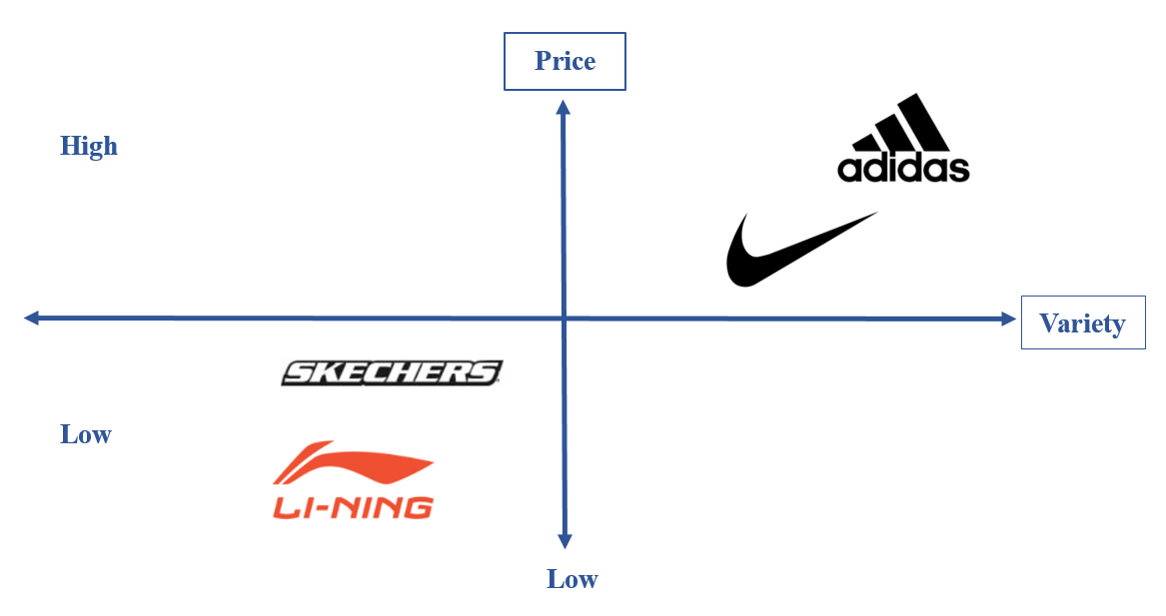

Figure 6: Low price & Low variety

*3.4.2. Cultural positioning*

For the cultural positioning, Li-Ning will be placed in the **Foreign consumer culture positioning**. It refers that the brand of Li-Ning is positioned as a strong Chinese brand for sports apparels due to the fame since 1992. Moreover, Li-Ning cannot be placed as Global consumer culture positioning due to the lack of reflecting the brand as a global consumer culture.

# Marketing mix

Product

*4.1.1. Product Life Cycle*

In China, Li-Ning’s products include sports footwear, apparel and accessories for sports. Especially in the market of Myanmar, Li-Ning will only focus on the shoes products. Hence, the Li-Ning’s product life cycle will be examined to indicate the specific product phase in Myanmar market. The Product Life Cycle – PLC outlines the different stages of a product that goes through from the introduction to decline which involves with changes in the marketing mix strategy to benefit the market share (Pettinger, 2018).

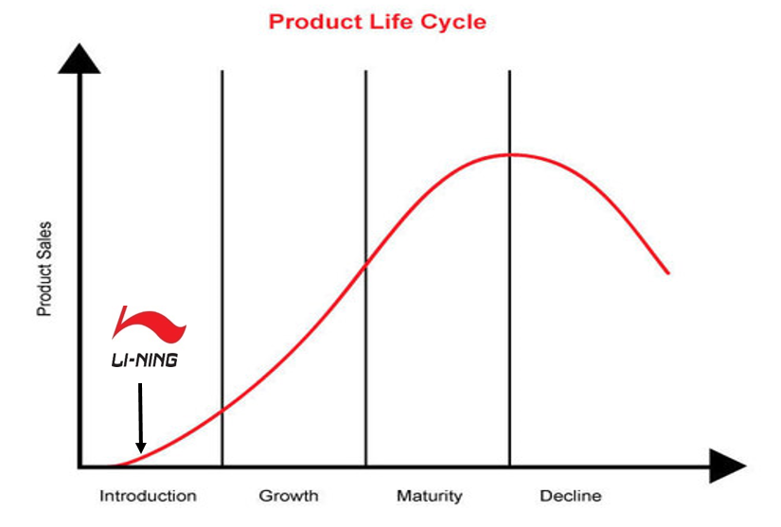

Figure 7: Product Life Cycle

According to Figure 7, Li-Ning’s product is recognized the introduction phases in Myanmar market. The marketing objectives of this stage is to let customers reach and purchase the products (Solomon et al, 2014).

*4.1.2. Product layer*

There is a specific description about Li-Ning’s product layer, which is provided in **Figure**

|  |  |
| --- | --- |
| **Layers** | **Description** |
| Core | Sports shoes |
| Actual | * Products brand and logo * The various color, textures, products size for exterior design * Small package of Silica desiccant * Highlight products quality |
| Augmented | * Company business card includes phone number and email address * Environmental product packaging * Warranty policy |

Figure 8: Product layer

Li-Ning offers the core product is sports shoes. The purpose is to deliver the high quality products that makes customers feel comfortable when participating the sports activities.

For the actual layer of product, the products brand and logo must be placed on the products that makes consumers recognize and pronounce straightforwardly. Different products design will provide some color and size to bring about more selection for the customers. There must have a small package of Sillica desiccant for moisture-proof function.

For the augmented layer, there must have a business card with purchased products where the customer support service hotline or email, the company address are provided to make consumers contact straightforwardly in case of emergency. There must have the bio-degradable package for storing the purchased products in order to reduce the drawback of environmental issue in Myanmar. Especially, in Yangon, Li-Ning will offer the 2-year warranty post purchase products, which creates the prestigious value to encourage the purchases intention of customer and build the trust relationship between Li-Ning and customer.

*4.1.3. Types of consumer products*

Li-Ning shoes belongs to the shopping product according to of the 4 types of consumer products. The product is that customer usually compares on attributes such as quality and price in the selecting and purchasing process (Claessens, 2017). In addition, the product of Li-Ning is less frequently purchase due to the feature of imperishability.

The local people will spend the time to search the product information and conduct the comparison with other alternatives brands like Nike, Adidas and Skechers and some sale domestic outlets in Myanmar.

*4.1.4. Product Standardization Strategy*

Li-Ning will make the product standardization for shoes products for some reasons. Firstly, sports shoes products are the common products that meet the customers’ needs which offers the ultimately comfortable level when participating the sports activities. Secondly, there is a similar Asian’s dimension about body between Chinese and Burmese people. Thirdly, the company can save the financial budget and further focus on building brand, implementing the planning and control policy.

*4.1.5. International product strategies*

Li-Ning will apply the **Product extension – communication adaptation** strategy. It means that there is a same product but using different types of communication strategy. There are some reasons for Product extension. It creates the benefit of reducing cost. Firstly, the standardization of Li-Ning shoes will reduce the risk since the same raw material being used, packaging and marketing techniques, the standardization of Li-Ning shoes will ensure the low cost of production and maintenance (Bhasin,2018). If Li-Ning customizes the product, the cost of gathering data and testing in Myanmar will increase dramatically.

Secondly, it will generate global uniformity and image. Through global uniformity when the product of Li-Ning shoes across the international markets, the standardization of Li-Ning shoes makes sure the same product and consistent in all its aspects, which builds the brand recognition.

The communication strategy between China and Myanmar market will be provided in **Figure**

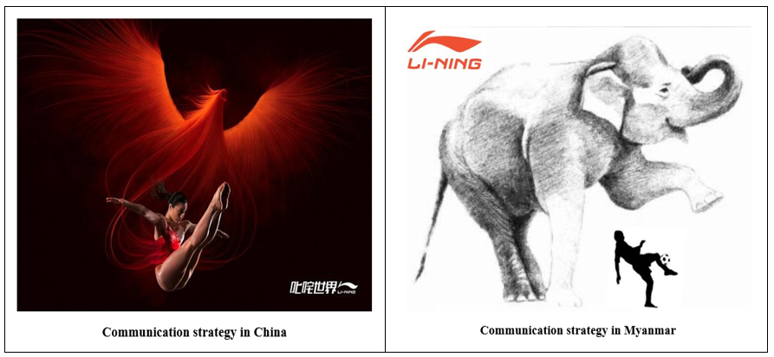

Figure 9: The comparison between two countries

From an overall perspective, the main aspect of communication strategy includes the iconic animals and types of sports activity of both countries advertisement. In China, Li Ning’s advertisement uses the image of Phoenix to express the strongly spiritual power of the wind. In sports, wearing Li Ning's products will make the sportsman become strong.

When entering Yangon, because of the different culture, social norms, there will have the difference in communication strategies. In Myanmar, the iconic animal will be replaced as the White elephants where the animal represents unique appearance the great blessings and fortune (WOODALL ADDO, 2016). Football is one of the most common sports activities in Myanmar. The meaning of this communication is that only Li-Ning brands will provide sports shoes will bring about the lucky for business performance and consumers with unique experience.

Place

The Li Ning’s outlet will be placed in Yangon city where there is a prime location with a lot of large shopping centers in Myanmar, which ensures that Li Ning’s business will reach a large number of target market.

*4.2.1. International logistics*

The home country for Li-Ning company is in China. There will transport products from the home country – China to the host country – Myanmar. This is also known as international logistics. It refers to the management of the global flow of goods and information that maximize the business objectives as well as keep costs low (Kotabe et al, 2014).

There are some international logistic challenges that Li Ning may face. Firstly, there the great distances between two countries, which is about more than 3000 km (Distance Yangon Shanghai - Air Line, Driving Route, Midpoint, n.d). Secondly, there is the risk of security in Myanmar market. Thirdly, the fluctuation of exchange rate between China and Myanmar will increases costs. Finally, some unpredictable natural disasters will delay the product transportation to Myanmar

*4.2.2. Modes of transportation*

There are two modes of transportation that are suitable for Li Ning to consider in the process of transferring goods to Myanmar. They are **Ocean shipping** and **Intermodal transportation**.

For the Ocean shipping, ocean freight is the most economical way of shipping where there is a long distance between two countries. The first advantage of this form is to allow the transfer of a great quantity of goods due to tremendous storage capacity and the requirement of low cost. Next, the delays rarely occur because ocean freight is not heavily affected by weather conditions. Furthermore, this form of transportation benefits for non-perishable products, which is suitable for sports shoes.

For the Intermodal transportation, it refers to the method of transferring goods through multiple vehicles such as rail, ship, truck… without any handling of the loads during the process of changing modes. This type of transportation has an advantage for Li Ning because it makes things easier when products are shifting from ocean to rail for local distribution.

*4.2.3. Technology assistance*

Thanks to the utilization of advanced technology called RPIF in logistics industry, it will help Li-Ning track the shipping products and enhance the products security until placing in the Yangon outlets. In case of unpredictable conditions, this technology will play a role of informing and detecting the lost item to both parties regarding Li-Ning business and logistic department.

*5.2.4. Channel configuration*

Li-Ning business will choose the **Direct channel** to sell in Yangon. This refers to the process of manufacturing the sports shoes products in China and transporting directly to the outlet in Yangon. Hence, all sale statistics will be kept confidentially and it reduces costs due to the absent of channel intermediaries.

Price

Due to the position of introduction stage about Li-Ning’s Product life cycle in Yangon, the business has some considerations about establish the price in Yangon. Firstly, the price may be higher to recover the R&D costs or lower to attract a large number of consumers, which depends on company performance (Solomon et al, 2014).

Secondly, there is a combination of promotion and price to create the strategy alternatives such as high price/high promotion, high price/low promotion, low price/low promotion, low price/high promotion (Jain et al, 2012).

Moreover, the price decision also depends on internal factors and external factors. For the internal factors, it includes that the marketing objectives of year 1 is to 15% market share in Myanmar, the costs of researching the Myanmar market, establishing the outlet at Yangon, the target market. For the external factors, it includes that Myanmar is still the developing countries where the capital income is low, the most of Myanmar people purchase the products for primary demand, there is a fierce competition between Adidas, Nike, Skechers, which has already established their business in Myanmar and the inconsistent government policy.

Therefore, the price of Li-Ning products will maintain when they enter the market due to the target market focusing on people with middle to high income. Through the currency exchange rate, the price of both countries is affordable for Myanmar people. To be more specific, the illustrated price comparison will be provided in Figure 10.

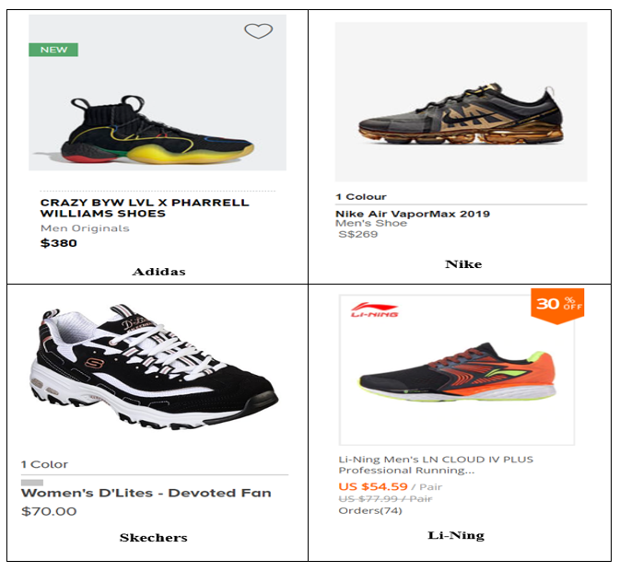

Figure 10: Price comparison

The price of Adidas costs about $380, which equals to SGD513. The price of Nike costs about $S269, which equals to SGD54. The price of Skechers costs about $70, which equals to SGD94. The price of Li-Ning costs about US$54.49, which equals to SGD74.75.

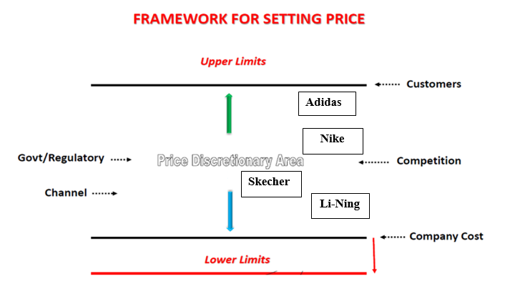

Figure 11: Price Framework

There is an overall price framework which is provided by Figure 11 . It is easy to notice that when Li-Ning runs the business in Myanmar, the price will be near the Lower limits which is known as Price floor. Some adjustments about marketing strategy, objectives, mix, nature of the market and demand, competition in the market will make the Li-Ning’s price framework fluctuate from the middle to the adjacent upper limits or price ceiling. It means that Li-Ning will become the first choice for local people when they buy the sports shoes

Promotion

Due to the fact that the Li-Ning’s Product life cycle is in the introduction stage in Myanmar market, it is essential to increase the frequency of advertising to gain consumer awareness about Li-Ning brand and encourage them to purchase products.

Through the research about Myanmar's media facilities and restrictions, it is vital to notice that the traditional advertising platform is the most influential media for Myanmar people. In addition, the Internet in Myanmar has increased significantly, but the penetration rate is not very high. Therefore, the combination traditional media methods with the Digital marketing is the best way to attract target customers.

*4.4.1. International advertising and culture*

From the above analysis about International product strategies and the advertisement illustrated in Figure, it proves that the Li-Ning has through comprehension about Myanmar culture in terms of the meaning of iconic animals and the favorite sports from the Myanmar people perspective.

*4.4.2. Advertising approach*

There is a selection of Platform approach where a central theme is an iconic animals and types of sports activities. As the above analysis, the local creative execution will be the replacement of iconic animals and types of sports activities, which is the White elephant and football in order to be suitable for Myanmar culture.

Overall, the Li-Ning business will use the Community Adaption to promote the products.

*4.4.3. International media decisions*

*4.4.3.1. Television*

The most popular channels in Myanmar are MRTV 4, Channel 7, MRTV and MWD where the MRTV 4 targets the audiences aging over 35. Channel 7 targets the young people. (The Nation, 2017). The prime slot time broadcast for each channel is similar, which is from 6 pm to 10 pm. The primes time billing rate is approximately Bt40,000 (The Nation, 2017).

Therefore, the Li-Ning business will advertise on Television for some following reasons. Firstly, the Myanmar people can watch the advertisement in the sight and sound manner which is displayed on plasma and LCD large-screen TVS, DVD players, DVRS. Secondly, television advertising reaches out to mass audience. Thirdly, the advertisement provides a creative message for the sports shoes products for target market and it can enhance the brand’s prestigious image.

The broadcast time is in the evening and night time which is from 6pm to 10pm due to the prime slot time and the interest of watching TV.

*4.4.3.2. Event sponsorship*

Li Ning sponsored the ASEAN Football Championship and became the major sponsor of the Singapore Open Badminton Tournament in 2013. In addition, Li Ning also sponsors various clubs. Due to the experienced about sponsor activities, when entering the Myanmar market, the business anticipates to sponsor the football clubs in Myanmar.

Football is one of the favorite sports of the Burmese. The sponsorship provided by Li Ning will offer to the sportsman the high quality and comfortable sports equipment to exercise. With the rapid development of the Myanmar economy, the local people also attach the special importance to nurture healthy sports and comfortable sports products (Lai, 2011).

*4.4.3.3. Social media*

4.4.3.3.1. Facebook

Facebook is the most popular social media in Myanmar. According to the statistics of Amara Digital Marketing Agency, Myanmar has more than 9.7 million monthly active users, which means that about 19% of the country's users are active on Facebook. According to the announcement of Ma Chan Myae Khine – the head of operations at the marketing agency, the Myanmar profile on the site could be three to four times more likely, with 4.7 million monthly active users.

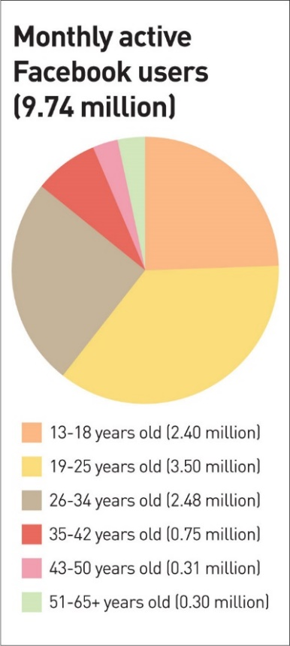

Figure 12: Monthly active Facebook users

According to the survey data of Yangon which is provided in Figure, it can be seen that the majority of users aging from 19 to 25 years old uses Facebook, which accounts for 3.50 million, followed by the age from 26 to 34, with a population of 2.48 million (The Myanmar Time, 2016). Therefore, Facebook ads are considered as the optimum social media advertising platform to reach potential customers.

Additionally, according to Myanmar's Facebook page statistics, the 7day News Journal, the Eleven Media Group and the BBC Burmese are three pages that draws a significant attraction from the local people and the highest click-through rate. Therefore, Li Ning will advertise the sports shoes products on these three websites, which will increase people's impression of the brand (Socialbakers, 2019).

It is undeniable that there is a significant impact on social media marketing, which can help to boost the revenue and brand awareness of Li-Ning. Not only does it provide people with fast result about an update on world events, it could even do something as simple as reminding people of their families and friends birthdays.

Through the powers of social media, we can also use the word of mouth among families and friends to help the business market efficiently through the aspect of Collectivist societies in Myanmar. They could input their recommendations to families and friends as our “potential customers” with a click of a button away.

By doing so, we could use Facebook to help us track and engage our customers who have visited our page and browsing our content and further entice these “potential customers” with promotion and discounts, making them hard to resist on our offer. Last but not least, Facebook operates 24/7 which means we can target anyone at any time as long as they have an internet connection

4.4.3.3.2. WeChat

In addition to Facebook, the number of WeChat users in Myanmar has gradually increased in recent years. MySQUAR is a Burmese social media, entertainment and payment platform. It announced that “it has signed a non-exclusive agreement to sell and promote WeChat's advertising products and services in Myanmar ("WeChat Agreement"). The WeChat agreement involves advertisements from Myanmar advertisers targeting Myanmar mainland Chinese visitors and WeChat Myanmar resident users” (Consult-Myanmar, 2018). This also provides Li-Ning about an additional platform to display goods and information, so that the WeChat users in Myanmar left a subconscious impression on Li-Ning business.

4.4.3.4 Outdoor advertising

Outdoor advertising such as billboards is also very effective to advertise the Li-Ning brand. Therefore, Li Ning will display its billboards on highways and bustling commercial streets.

In China, Li Ning’s advertisement appeared in Phoenix. The appearance of phoenix in advertising means the omnipresent and spiritual power of the wind. In sports, wearing Li Ning's products will have a strong athletic power. In Myanmar, we changed the animals in the advertisement and changed the phoenix to a white elephant. In Myanmar, the white elephant is a very sacred position, symbolizing the representative of power. Therefore, in order to better integrate Li Ning into Myanmar, the animals in the advertisement will be replaced by white elephants.

*5.4.3.5. Public relations*

To attract the target market of young people, Li Ning needs to create more targeted marketing campaigns with the use of Celebrity endorsements, come up with more creative advertising as well as strengthen its brand awareness and identity to be able to stand out in the market; especially, in a market as Myanmar where many international brands are encouraged to come in.

To be more specific, first and foremost, the growing trend in sportswear, music, film or sport celebrities can be a great source to influences young targets. Thus, Li Ning should use celebrity endorsement to rejuvenate the brand image and expand its potential consumer groups.

Furthermore, Li Ning should collaborate with a local marketing agency in order to prevent risks arising from cultural barrier which can result in significant drawbacks when running business in Myanmar market.

# Budget

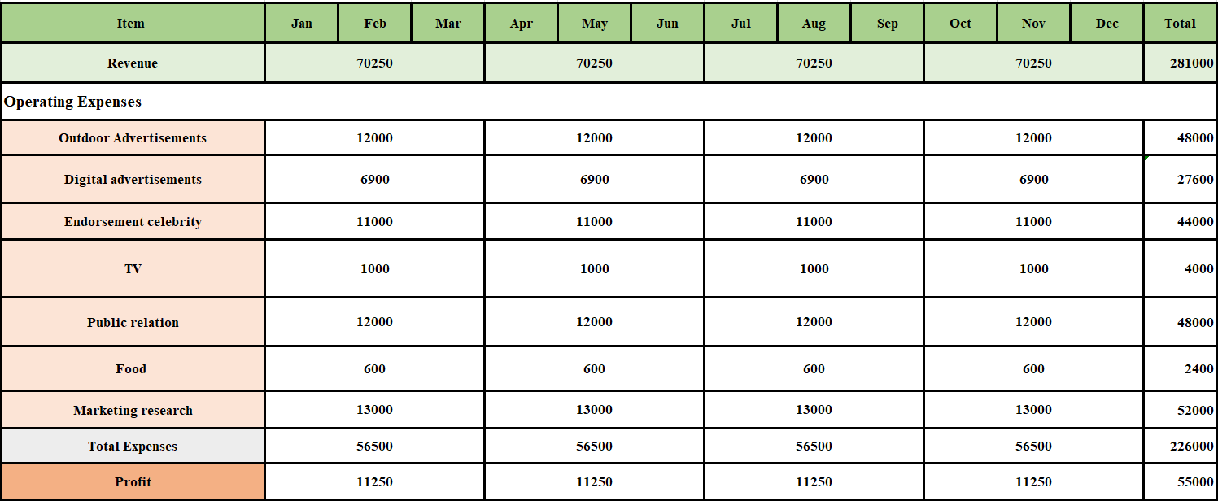

# Marketing control

***6.1. Control plan***

*6.1.1. What to measure?*

For the qualitative objective, Li-Ning will become the leader of providing sports apparel with reasonable price and high quality in Myanmar and focus only the target market who had high income to express the world-class business.

For quantitative objective, Li-Ning aims to get the revenue of SGD$281,000 in 2020 where there is about achieving 50% of brand awareness from the target customers and 15% market share of sports brand in Myanmar.

*6.1.2. How to measure?*

In order to gain the projected revenue, based on the budget the business the business will allocate the finance for operating expenses includes Outdoor Advertisements, Digital Advertisement, TV, endorsement advertisement, Public Relation and social media.

6.1.3. When to measure?

Through the Budget, the business will measure by quarterly per year with the head office and staffs due to the fact that this is the first time enter Myanmar market, the target market belongs to upper class.

***6.2. Contingency control***

When running the business in Myanmar, Li-Ning should prepare some policy to deal with unpredictable condition including **Low-skilled workers, Insufficient experts, Low management expertise, Erratic cost of raw material, Boycott or Scandal, Combating privacy**. For the Low-skilled workers, Insufficient experts, Low management expertise, the problem is common to happen. Li-Ning should provide the basic training and knowledge transfer for employees. In addition, for the problem of lacking experts, it is necessary that Li-Ning company distributes the experts both in management and operation from Beijing (headquarter) to Myanmar.

For the Erratic cost of raw material, Li-Ning should formulate a two-pronged strategy to counter. The incorporate detailed cost tracking must be required and the procurement departments of Li-Ning need to become agile and adept within the full gambit of derivative instruments. The waste minimization technologies and program also should be considered.

For the Boycott or scandal, the lack of knowledge about culture in Myanmar will affect the communication strategy such as the cultural violation and unprofessional customer service. When it happens, the representatives of business will admit the false, apologize the publics through press conference and must take action so solve the problem immediately.

For combating privacy, it is the common problem in some parts of Asian countries. First and foremost, Li-Ning must gain the certificate about brand through trademark from the Myanmar government, which obtains the business justification. The employment about domestic lawyer will help Li-Ning comprehend clearly about the nature condition in Myanmar as well as get the useful advice from the government policy.

***6.3. Expansion plan***

In the assumption of successful entry of Li-Ning at the Myanmar market, the plan for the expansion is the strategic exercise and the implementation of a strong expansion strategy is required to meet the increase in demand, efficiencies, new production lines, more diverse or international markets (Bryant, n.d.). Keeping the growth stage of Li-Ning product life-cycle is important in the expansion plan. Li-Ning should maintain the high quality of the product and improve the product feature to keep the brand loyalty that benefits of word-of-mouth and appealing the new customer. In addition, Li-Ning should increase the demand for the product to get a higher profit for the company. The distribution also is the key factor in the expansion, Li-Ning should increase the distribution channel and make the distribution more intensive. Li-Ning should have more outlets in the popular cities of Myanmar to become the major sports brand and take more market share in Myanmar market.

# Conclusion

There are some challenges that Li-Ning will encounter when they enter Myanmar market such as the inconsistent government policy, the environmental issue, culture barrier and the technology performance. To run the business successfully, the consumer behavior must be outlined clearly that help the business address the problems arising from the local people, which helps Li-Ning achieve higher level of brand awareness, revenue, target market. It is essential to increase the frequency of promotion, adjust the price strategy according to the change of internal and external environment, monitor the distribution process and indicate the specific phase of product life cycle to apply the suitable marketing strategy when running the business in Myanmar.

**References**

AIG. (2018). *Myanmar - Business Environment & Risk Analysis*. Retrieved from <https://www.aig.com/knowledge-and-insights/k-and-i-aricle-myanmar-business-environment-and-risk>

ASEAN Today. (2017). *Myanmar Government Relaxes Restrictions on Foreign Investment*. Retrieved from <https://www.aseantoday.com/2017/12/myanmar-government-relaxes-foreign-investment-restrictions/>

Bhasin, H. (2018). *What is product standardization? Uses and Advantages.* Retrieved from <https://www.marketing91.com/what-is-product-standardization-uses-and-advantages/>

Bryant, B.G. (n.d.). How to Plan a Business Expansion? Retrieved from <https://smallbusiness.chron.com/plan-business-expansion-153.html>

BusinessWire. (2017). *PESTLE Analysis of Myanmar 2017 - Research and Markets*. Retrieved from <https://www.businesswire.com/news/home/20170913005937/en/PESTLE-Analysis-Myanmar-2017---Research-Markets>

Claessens, M. (2017). *4 Types of consumer products and marketing considerations- convenience, shopping, specialty and unsought products.* Retrieved from <https://marketing-insider.eu/4-types-of-consumer-products/>

Chau, T. (2017). *One Third of Myanmar’s Population Remains in Poverty*. Retrieved from<https://www.mmtimes.com/news/one-third-myanmars-population-remains-poverty.html>

CNN Business. (2015). *How Nike Became King of Endorsements*. Retrieved from <https://money.cnn.com/2015/06/05/news/companies/nike-endorsement-dollars/index.html>

Consult-Myanmar. (2018). *MYSQUAR Agrees to Sell Advertising on Wechat in Myanmar*. Retrieved from <https://consult-myanmar.com/2018/10/15/mysquar-limited-agreement-to-sell-advertising-on-wechat-in-myanmar/>

Distance Yangon Shanghai - Air Line, Driving Route, Midpoint. (n.d). Retrieved from <https://www.distance.to/Yangon/Shanghai>

Directorate of Investment and Company Administration. (2019). *Why Invest in Myanmar?* Retrieved from <https://www.dica.gov.mm/en/why-invest-myanmar>

Environmental, Social and Governance Report. (2014). Retrieved from <http://ir.lining.com/en/csr/csr_reports/csr_report_2014.pdf>

Escande, M. (2014). Li-Ning Strategic Recommendation USA 2015. Retrieved from <https://www.slideshare.net/marinescnd/lining-strategy-usa-2015>

Euler Hermes. (2018). *Myanmar (Burma)*. Retrieved from <https://www.eulerhermes.com/en_global/economic-research/country-reports/Myanmar.html>

Gu, J. (2018). *Fact& Figure of The Biggest Chinese Fashion Companies: Li-Ning.* Retrieved from <https://fashionunited.uk/news/business/facts-figures-of-the-biggest-chinese-fashion-companies-li-ning/2018082138412>

Helsingen, H. (2018). *Time for Myanmar to Beat Plastic Pollution*. Retrieved from <https://www.mmtimes.com/news/time-myanmar-beat-plastic-pollution.html>

Hynes, C. (2017). *Internet Use is on the Rise in Myanmar, But Better Options Are Needed*. Retrieved from <https://www.forbes.com/sites/chynes/2017/09/22/internet-use-is-on-the-rise-in-myanmar-but-better-options-are-needed/#25027134448e>

Jain, S., Haley, G., Voola, R. & Wickham, M. (2012) *Marketing Planning and Strategy (1e)*. Victoria: Cengage Learning.

Kar. (2011). *Market entry strategy for international business.* Retrieved from <http://www.business-fundas.com/2011/market-entry-strategy-for-international-business/>

Kotabe, M., Marshall, Al., Ang, S., Griffiths, K., Voola, R., Roberts, R & Helsen, K. (2014). International *Marketing, 4th Asia Pacific Edition*. John Wiley & Sons Australia, Ltd: Milton, Qld.

Lai, G. (2011). *Susilo Gets Three-Year Li-Ning Sponsorship*. Retrieved from [http://www.asiaone.com/News/Latest News/Sports/Story/A1Story20110218-264151.html](http://www.asiaone.com/News/Latest%20News/Sports/Story/A1Story20110218-264151.html)

LI-NING. (n.d.). Retrieved from <http://ir.lining.com/en/global/index.php>

Li Ning. (n.d.). *Careers in Asia.* Retrieved from <http://www.careersinasia.com/company/li-ning/>

Myanmar Population. (2018). Retrieved from<https://countrymeters.info/en/Myanmar>

Marketing91. (2017). *Marketing Strategy of Adidas*. Retrieved from <https://www.marketing91.com/marketing-strategy-of-adidas/>

MyanmarTimes. (2016). *Myanmar's Air Pollution Among the Worst in the World: WHO*. Retrieved from <https://www.mmtimes.com/national-news/22840-myanmar-s-air-pollution-among-the-worst-in-the-world-who.html>

Nembhard, C. (2018). *Nike Remains World’s Most Valuable Apparel Brand in 2018*. Retrieved from <https://www.highsnobiety.com/p/nike-most-valuable-apparel-brand-2018/>

Nie, W., Lu, A. & Dowell, W. (2012). *In the Shadow of the Dragon: The Global Expansion of Chinese Companies--and How It Will Change Business Forever. Risk Management.* Retrieved from <https://books.google.com.sg/books?id=g5Lp3VifNHcC&pg=PA145&lpg=PA145&dq=Li-Ning+has+more+than+7000+store&source=bl&ots=Hugv60zx-T&sig=18VKuIgUlDlk2nbK4WvA1O_jHdw&hl=zh-CN&sa=X&ved=2ahUKEwi2sMzs4sffAhVSXSsKHXbKAkMQ6AEwCHoECAMQAQ#v=onepage&q=Li-Ning%20has%20more%20than%207000%20store&f=false>

Numbeo. (2018). Retrived from <https://www.numbeo.com/pollution/country_result.jsp?country=Myanmar>

Socialbakers. (2019). Most Popular Facebook Pages in Myanmar. Retrieved from <https://www.socialbakers.com/statistics/facebook/pages/total/myanmar/>

Solomon, M., Hughes, A., Chitty, B., Fripp, G., Marshall, G. & Stuart, E. (2014). *Marketing 3: Real People, Real Choices*. Frenchs Forest: Pearson Education Australia.

The Myanmar Times. (2012). *Change Yourself, Change The Nation*. Retrieved from <https://www.mmtimes.com/opinion/3546-change-yourself-change-the-nation.html>

The Myanmar Times. (2016). *Facebook Racks Up 10m Myanmar Users*. Retrieved from <https://www.mmtimes.com/business/technology/20816-facebook-racks-up-10m-myanmar-users.html>

The Myanmar Times. (2018). *Top 10 predictions for Myanmar property sector in 2018: Colliers*. Retrieved from <https://www.mmtimes.com/news/top-10-predictions-myanmar-property-sector-2018-colliers.html>

The World Bank. (2017). *New Investment Law Helps Myanmar Rebuild its Economy and Create Jobs*. Retrieved from <http://www.worldbank.org/en/news/feature/2017/01/25/new-investment-law-helps-myanmar-rebuild-its-economy-and-create-jobs>

The World Bank. (2018). *The World Bank in Myanmar*. Retrieved from<https://www.worldbank.org/en/country/myanmar/overview>

Participation in Sport and Active Recreation. (n.d). *NSW Government.* Retrieved from <https://sport.nsw.gov.au/sectordevelopment/participation>

PWC. (2017). *Myanmar Public Asset Business Guide*. Retrieved from:<https://www.pwc.com/mm/en/publications/assets/myanmar_business_guide.pdf>

World Population Review. (2018). *Population of Cities in Myanmar*. Retrieved from <http://worldpopulationreview.com/countries/myanmar-population/cities/>

Parker, E. (2016). *Myanmar’s Opening: Doing Business in Asia’s Final Frontier*. Retrieved from <https://thediplomat.com/2016/11/myanmars-opening-doing-business-in-asias-final-frontier/>

Pettinger, T. (2018). Product life-cycle. *Economicshelp*. Retrieved from <https://www.economicshelp.org/blog/140934/business/product-life-cycle/>

The Nation. (2017). *TV 'Most Powerful Tool for Marketers' in Myanmar*. Retrieved from <http://www.nationmultimedia.com/business/TV-most-powerful-tool-for-marketers-in-Myanmar-30214587.html>

THIHA. (2018). *MYSQUAR Agrres to Sell Advertising on WeChat in Myanmar*. Retrieved from <https://consult-myanmar.com/2018/10/15/mysquar-limited-agreement-to-sell-advertising-on-wechat-in-myanmar/>

Thongtep, W. (2013). *TV ‘Most Powerful Tool for Marketers’ in Myanmar*. Retrieved from <http://www.nationmultimedia.com/business/TV-most-powerful-tool-for-marketers-in-Myanmar-30214587.html>

Withers, B. (2017). Skechers Company Stores Provide Strategic Advantages. Retrieved from <https://www.fool.com/investing/2017/02/16/skechers-company-stores-provide-strategic-advantag.aspx>

WOODALL ADDO. (2016). Legends of the White Elephant. Retrieved from <https://www.woodall-addo.co.za/legends-white-elephant/>

**Success! Your submission appears on this page. The submission confirmation number is d7082ee4-ee34-46d6-a0e4-256c59bc6e65. Copy and save this number as proof of your submission.**[**View all of your submission receipts in My Grades.**](https://learn.jcu.edu.au/webapps/bb-mygrades-BB5a1f6a34a2e8d/myGrades?course_id=_93818_1&stream_name=mygrades&is_stream=false)